Australian fiscal projections: 2026 update
Modular methodology, official-forecast bridge, projection scenarios and forecast checks
Generated 23 August 2026
All ratios are shares of nominal GDP unless otherwise stated. Financial years are labelled by their June-ending year.

Executive summary
The workflow deliberately separates the short-run official forecast from the long-run projection. The PBO 2026-27 National Fiscal Outlook supplies the consolidated general-government anchor through 2029-30. Bottom-up and top-down models are also run without that anchor over the same years, so their difference from the official forecast is visible rather than hidden.
- In the central bottom-up scenario, primary expenses rise to 39.4% of GDP and net debt reaches 75.2% by 2065-66.
- The pressure and restraint debt endpoints are 298.4% and -13.9%, illustrating that these are conditional scenarios, not confidence bounds.
- Holding revenue/GDP at the post-forecast level as a proxy for fully indexed personal-tax thresholds raises the central-spending debt endpoint to 115.4%.
- The seven top-down models behave differently because some model the spending ratio in levels, some model annual changes, the ECM combines long-run levels with short-run changes, and one contains no economic or demographic drivers.
- The univariate benchmark performs best against the short official forecast in this vintage, but that largely reflects near-term mean reversion; it is not evidence that a driver-free model is the most informative long-run structural projection.
Recommended hierarchy: retain the published consolidated forecast for the official forecast period; use the bottom-up purpose model as the central long-run fiscal projection; use the dynamic-difference specification as the primary driver-based top-down cross-check; retain the ARIMA with COVID controls as a near-term statistical benchmark; treat the current ARDL error-correction specification as experimental; and use the full scenario/model spread for uncertainty analysis.
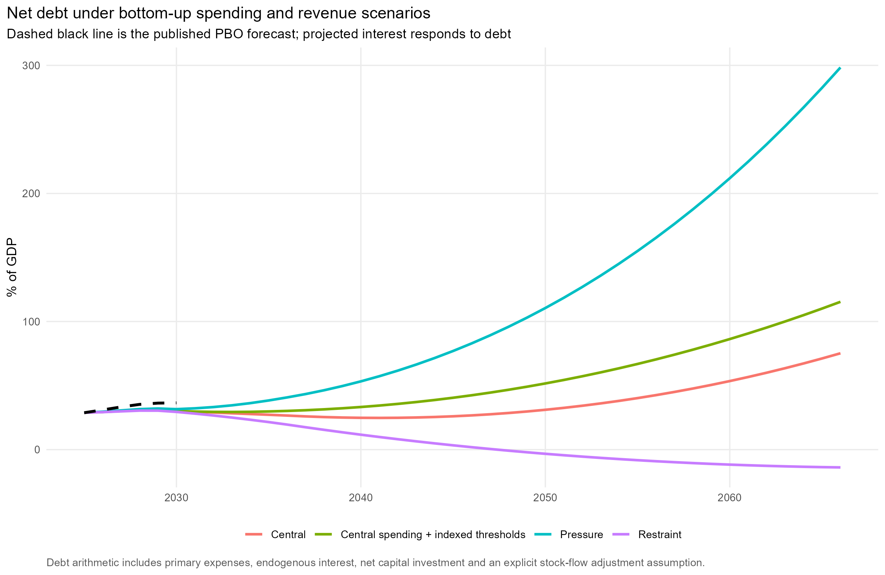
Figure 1. Bottom-up net debt paths under the spending, revenue and financing scenarios.

1. Workflow and reproducibility
Run run_all.R from the 2026 projections folder. Each script reads stored inputs and writes explicit intermediate files, so individual stages can be inspected or rerun independently.
Script | Purpose
01_download_data.R | Download/cache official inputs and write a source manifest.
02_clean_data.R | Clean annual data, construct fiscal concepts and run validation checks.
03_assumptions.R | Define macro, demographic, spending, revenue and financing scenarios.
04_official_forecast.R | Extract the PBO consolidated forecast anchor.
10_bottom_up_projection.R | Project GFS purpose categories and aggregate primary expenses.
20_top_down_projection.R | Estimate seven aggregate time-series alternatives and anchor their changes.
21_shapley_attribution.R | Average structural-factor contributions over every ordering for historical attribution.
30_forecast_checks.R | Run rolling historical tests and model-only checks over the official forecast.
31_model_diagnostics.R | Test fit and residuals; calculate coefficient standard errors, conditional intervals and sensitivities.
32_ecm_validation.R | Test ECM integration order, the finite-sample bounds relationship, residual specification, stability and collinearity.
40_revenue_and_debt.R | Apply revenue assumptions and the debt accumulation identities.
50_graphs.R | Generate PNG and SVG figures grouped by analytical task.
60_word_report.R | Assemble this methodology and results document.
Raw downloads are cached. Set REFRESH_DATA=true before running to force a refresh. The source manifest records the URL, local file, file size and check time. PNG files support quick review; matching SVG files support publication-quality editing.

2. Data, vintages and accounting concepts
Historical aggregate spending and macro variables come primarily from ABS national accounts. Purpose-level spending uses the ABS Government Finance Statistics annual general-government table for all levels of government. Demographic projections use the Centre for Population 2025 Population Statement. The official forecast uses the PBO 2026-27 National Fiscal Outlook, which consolidates the 2026-27 Commonwealth, state and territory budgets.
Source | Vintage_or_file | URL
gfs_annual | abs_gfs_annual_2024_25.xlsx | https://www.abs.gov.au/statistics/economy/government/government-finance-statistics-annual/2024-25/55120DO021_202425.xlsx
population_projection | population_statement_2025_age_sex.xlsx | https://population.gov.au/sites/population.gov.au/files/2026-01/2025-population-statement-age-sex-structure.xlsx
pbo_nfo | pbo_national_fiscal_outlook_2026_27.xlsx | https://www.pbo.gov.au/sites/default/files/2026-08/PBO%202026-27%20National%20Fiscal%20Outlook%20-%20Data.xlsx
budget_nominal_gdp | budget_2026_27_nominal_gdp.xlsx | https://budget.gov.au/content/bp1/download/bp1_s2-data-nominal-GDP.xlsx
budget_receipts_cash | budget_2026_27_cash_receipts.csv | https://budget.gov.au/content/bp1/download/bp1_s5-online_t1.csv
budget_receipts_gdp | budget_2026_27_receipts_gdp.csv | https://budget.gov.au/content/bp1/download/bp1_s5-online_t2.csv
labour_force_table1 | abs_labour_force_may_2026_table1.xlsx | https://www.abs.gov.au/statistics/labour/employment-and-unemployment/labour-force-australia/may-2026/62020001.xlsx
abs_5206 | abs_52060.rds | ABS Australian National Accounts 5206.0
abs_3101_table59 | abs_31010.rds | ABS National, state and territory population 3101.0 Table 59
abs_5302_table5 | abs_53020.rds | ABS Balance of Payments 5302.0 Table 5
Concept bridge: the national-accounts top-down series is broad government final consumption plus public investment, whereas the PBO/GFS expense measure also reflects transfers and other operating expenses. The workflow does not equate these levels. It shows unanchored national-accounts model paths for diagnosis, then adds each model's post-forecast change to the PBO expense ratio at the join.
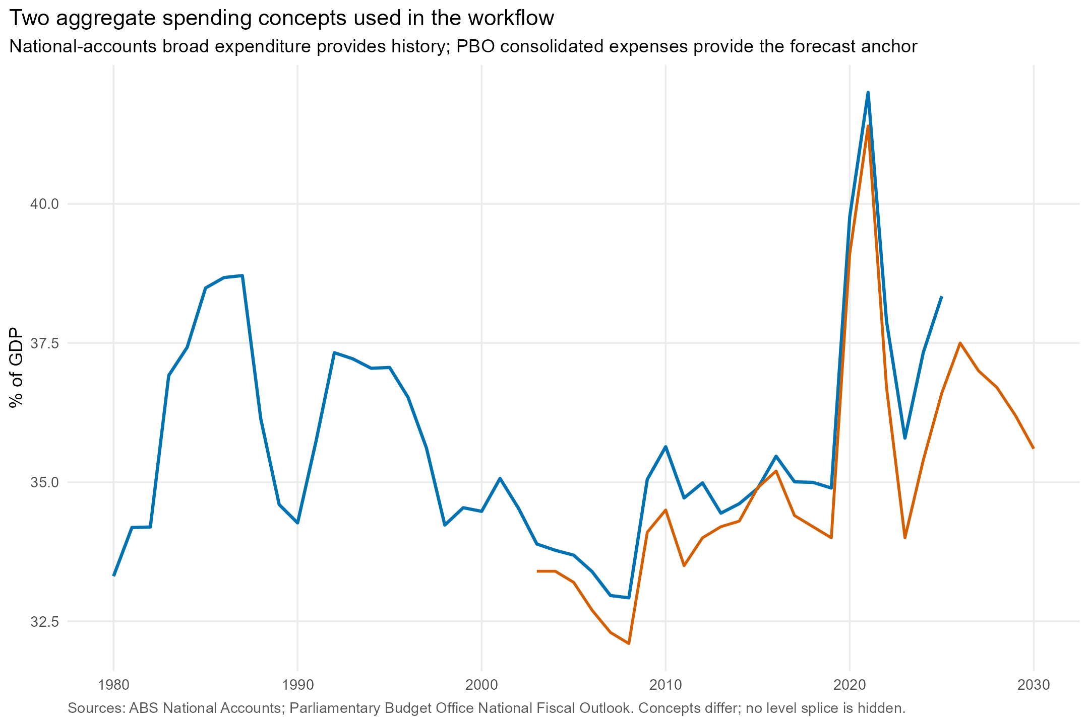
Figure 2. Historical spending concepts and the official expense forecast.

3. Cleaning and validation
Quarterly and monthly series are converted to financial years only where all periods are present. ABS revision-only duplicate series are excluded. Population is filtered to persons so male, female and persons series are not added together. GFS purpose categories are checked against total expenses, and historical and projected age shares must sum to one.
Check | Passed | Detail
Historical population not doubled | Yes | Latest population: 27.61 million
Historical age shares sum to one | Yes | Maximum absolute deviation: 0
Projection age shares sum to one | Yes | Maximum absolute deviation: 0
No partial financial years in national accounts model data | Yes | Latest complete merged financial year: 2025
GFS purpose categories add to total expenses | Yes | Difference ($m): 0
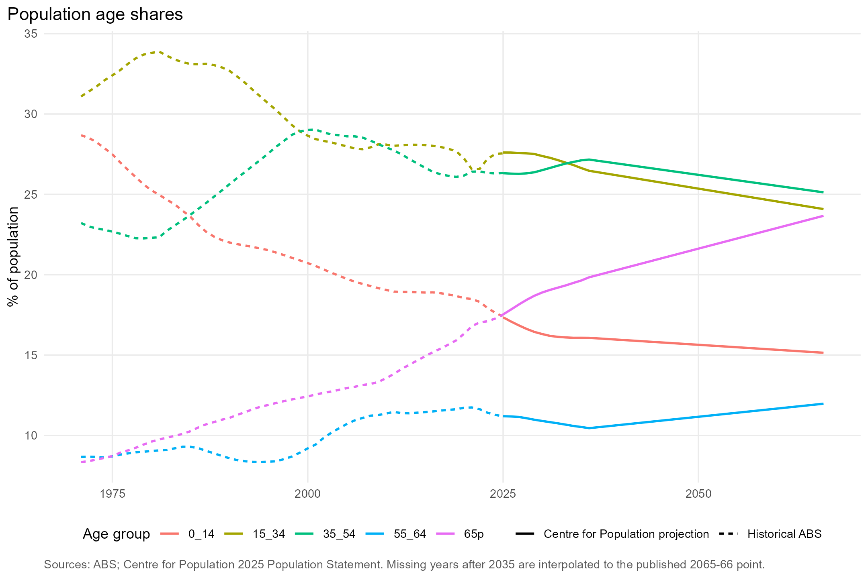
Figure 3. Historical and projected age composition.

4. Official forecast anchor and projection join
For 2025-26 to 2029-30, the published PBO consolidated expenses, revenue, net capital investment, public debt interest and net debt ratios are used. From 2030-31, the structural projection supplies changes. This separates an official forecast containing policy, near-term macro judgement and detailed budget information from a stylised long-run projection.
Financial year | Status | Expenses / GDP | Revenue / GDP | Public debt interest / GDP | Net debt / GDP
2024-25 | Historical/actual | 36.6% | 36.3% | 1.5% | 28.8%
2025-26 | Official forecast | 37.5% | 36.3% | 1.6% | 31.0%
2026-27 | Official forecast | 37.0% | 36.7% | 1.8% | 33.3%
2027-28 | Official forecast | 36.7% | 36.4% | 2.0% | 35.3%
2028-29 | Official forecast | 36.2% | 35.8% | 2.1% | 36.3%
2029-30 | Official forecast | 35.6% | 35.7% | 2.2% | 36.5%
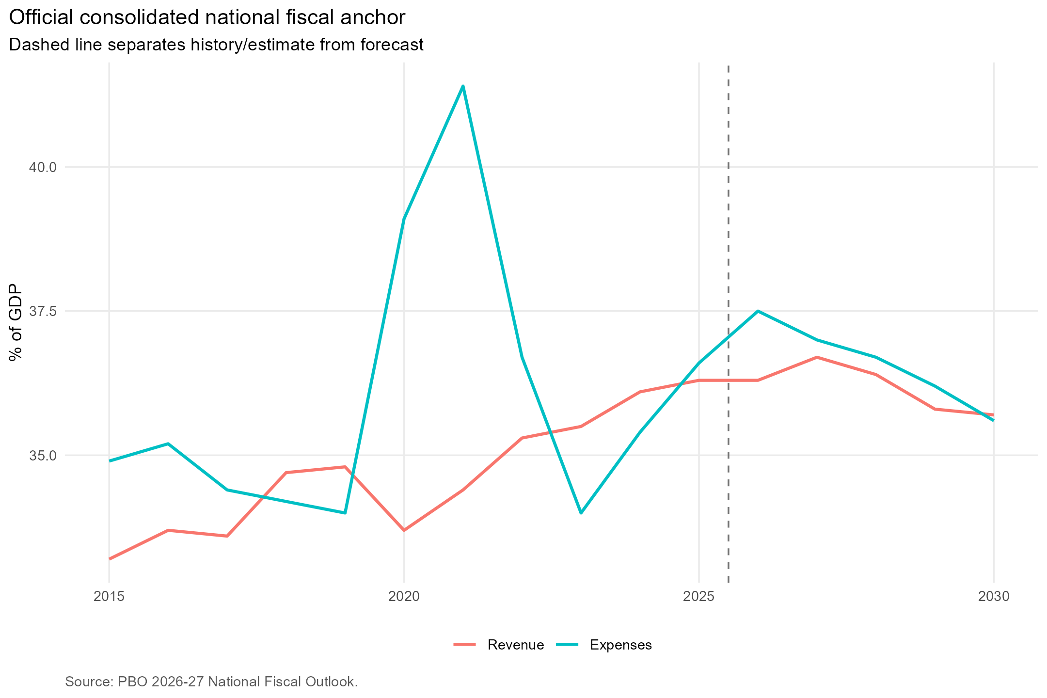
Figure 4. Official consolidated revenue and expense ratios used as the short-run anchor.

5. Bottom-up spending projection
The bottom-up model starts with ABS GFS expenses by purpose. Public debt interest is removed from general public services, leaving primary expenses. Each category is projected from a service-demand exposure base and a category-specific excess-cost assumption. Health exposure weights older age groups; education weights younger age groups; social protection combines age groups; most remaining categories use total population. Defence follows an explicit GDP target.
For a non-defence category j, the core recursion is E[j,t] = E[j,t-1] * (X[j,t] / X[j,t-1]) * (1 + economy-wide productivity and inflation growth + category excess cost). The economy-wide component prevents all per-person services from mechanically shrinking relative to GDP. Excess costs represent price, wage, technology, intensity or policy pressures above that baseline.
During the official forecast years the category values are proportionally scaled to PBO total expenses less PBO public debt interest. After 2029-30 the categories determine the aggregate. The raw, unscaled path is retained and used in the forecast-period checks.
Category | Exposure base | Central | Pressure | Restraint
General public services excl interest | total_population | 0.0% | 0.2% | -0.2%
Defence | gdp_target | Target rule | Target rule | Target rule
Public order and safety | total_population | 0.2% | 0.5% | 0.0%
Economic affairs | total_population | 0.0% | 0.2% | -0.2%
Environmental Protection | total_population | 0.0% | 0.2% | -0.2%
Housing and community amenities | total_population | 0.0% | 0.2% | -0.2%
Health | health_age_weight | 0.8% | 1.2% | 0.2%
Recreation, culture and religion | total_population | 0.0% | 0.2% | -0.2%
Education | education_age_weight | 0.2% | 0.5% | 0.0%
Social Protection | social_age_weight | 0.2% | 0.8% | 0.0%
Transport | total_population | 0.0% | 0.2% | -0.2%
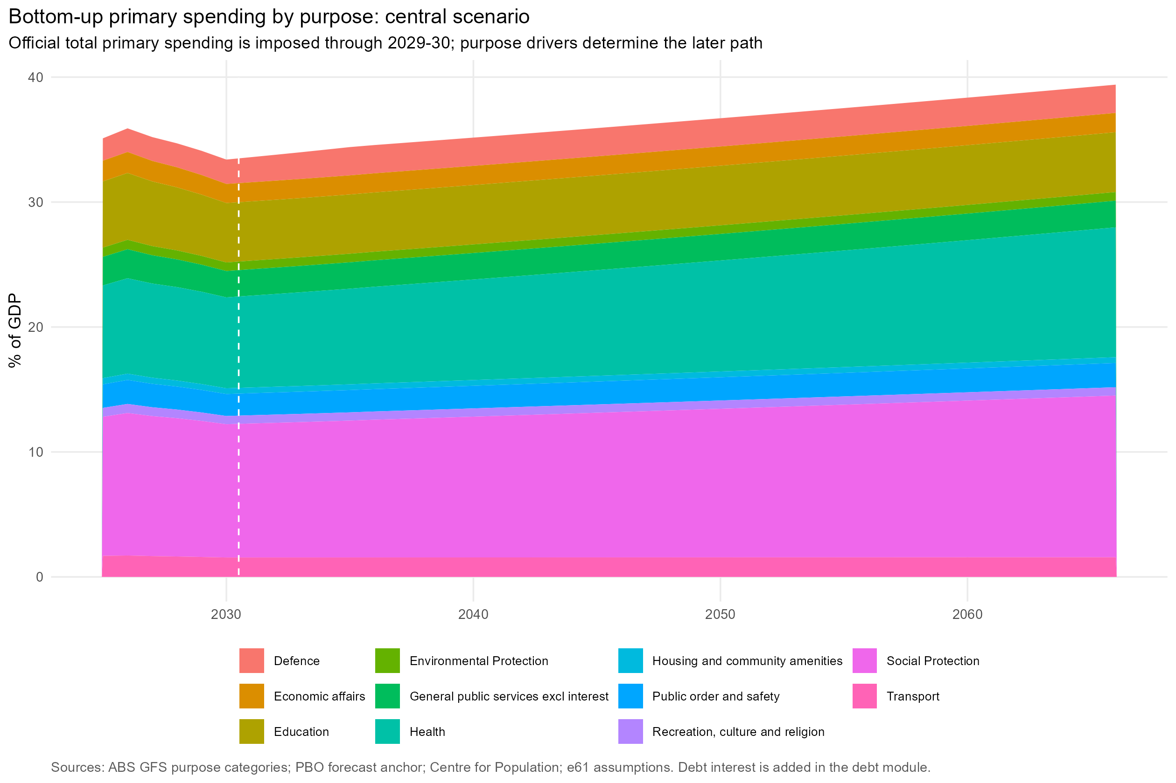
Figure 5. Central bottom-up primary spending by GFS purpose.
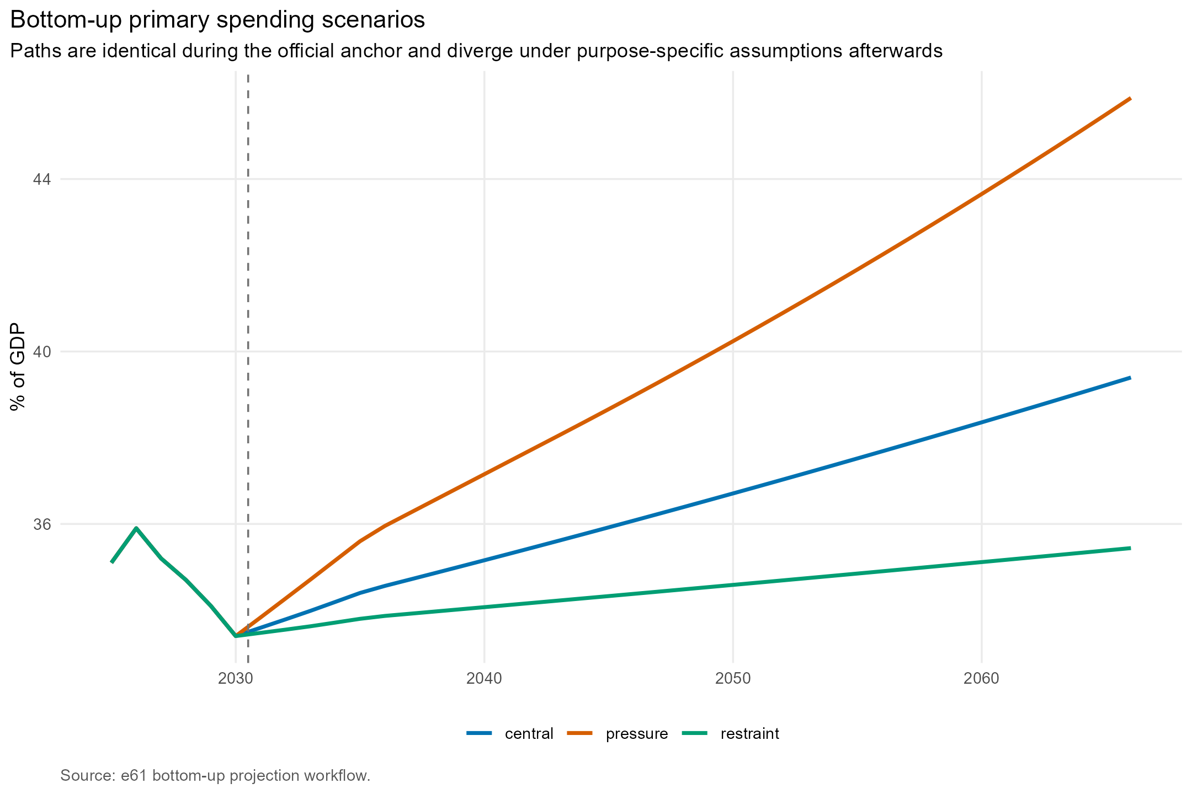
Figure 6. Bottom-up primary spending scenarios.

6. Top-down aggregate projections
The top-down models use the national-accounts broad spending ratio. Age shares, terms of trade, the relative government-consumption price, unemployment and the COVID period provide possible economic and demographic drivers. Standardisation is fixed using the pre-COVID 1980-2019 sample so later observations do not redefine the scale.
Model | Mechanism | Why paths differ
Structural OLS (levels) | Spending/GDP is a level function of the 0-14 and 65+ population shares, terms of trade, relative government prices and unemployment, with separate FY2020-22 indicators. | Persistent changes in driver levels permanently alter the spending ratio and coefficient uncertainty can dominate far from the sample.
ARIMAX (levels) | The same level relationship is combined with autocorrelated errors selected by AICc. | Mean reversion in the ARIMA error pulls the path toward the fitted structural level.
ARIMAX (differences) | Annual changes in spending/GDP respond to annual changes in the drivers; projected changes are accumulated from the last observation. | No deterministic drift is imposed, so stable future drivers make annual changes fade; early changes remain embedded in the level.
Dynamic differences | Annual changes use variable-specific dynamics and lags, with separate FY2020-22 annual-change indicators. | Tailored transformations avoid treating every driver identically, but forecast errors still accumulate in the projected level.
Hybrid structural/macro | The selected age shares, relative government prices and FY2020-22 indicators determine a structural level component; macro changes explain movements around it. | Slow structural pressures create a gradual trend while temporary macro impulses fade.
ARDL error-correction model | Annual spending growth responds to disequilibrium in lagged spending and structural levels, short-run macro changes and separate FY2020-22 indicators. | The estimated speed of adjustment pulls spending toward an implied long-run relationship while retaining short-run dynamics.
ARIMA with COVID controls | Spending/GDP is forecast from its own history after absorbing FY2020-22 with separate indicators. | Without structural drivers it tends to revert toward its estimated historical process and can appear comparatively flat.
Model | Specification | ARIMA order | AIC | AICc | BIC | Observations
Structural OLS (levels) | y ~ age_0_14 + age_65p + tot_z + rp_z + unemployment + covid_fy2020 + covid_fy2021 + covid_fy2022 |  | -270.0 | n/a | -251.7 | 46
ARIMAX (levels) | Spending/GDP in levels with age and macro xreg; stationary ARMA errors | 2,0,0 | -311.8 | -304.0 | -291.7 | 46
ARIMAX (differences) | Benchmark: annual change in spending/GDP with differenced drivers and FY2020-22 interventions; no drift | 0,0,0 | -305.3 | -300.1 | -289.0 | 45
Dynamic differences | Change in spending/GDP with selected d(age shares), d(relative prices), d(unemployment) + lag, d(TOT) + lag, FY2020-22 interventions; ARMA errors | 0,0,0 | -295.0 | -286.7 | -275.3 | 44
Hybrid structural/macro | Structural level OLS using selected age shares + relative prices + FY2020-22 interventions; macro residual change uses d(unemployment) + lag and d(TOT) + lag; ARMA errors | 0,0,0 | -293.3 | -291.7 | -284.4 | 44
ARDL error-correction model | dy ~ y_lag + age_0_14_l1 + age_65p_l1 + rp_z_l1 + d_rp_z + unemployment_l1 + d_unemployment + d_tot_z + d_tot_z_l1 + dy_lag + covid_fy2020 + covid_fy2021 + covid_fy2022 |  | -293.0 | n/a | -266.2 | 44
ARIMA with COVID controls | Automatic ARIMA benchmark with FY2020-22 interventions | 1,0,2 | -298.2 | -294.4 | -283.6 | 46
Information criteria are reported within each specification. They should not be used to rank models with different dependent-variable transformations; rolling pseudo-out-of-sample errors provide the cross-model forecast comparison.
The ECM adjustment coefficient is negative in this vintage, indicating dynamically convergent conditional forecasts. A negative coefficient is necessary but not sufficient evidence for a valid level relationship. The implied long-run coefficients below are diagnostics from the unrestricted ECM parameterisation, not a separate model.
Term | Implied long-run estimate | Adjustment coefficient
(Intercept) | -0.2627 | -0.2381
age_0_14 | 1.7616 | -0.2381
age_65p | 1.8198 | -0.2381
rp_z | -0.0031 | -0.2381
unemployment | 0.0031 | -0.2381

ECM validity checks
The ARDL bounds approach permits a mixture of I(0) and I(1) regressors but not I(2) variables. ADF and KPSS tests are therefore used to assess integration order, followed by finite-sample Case III bounds F- and t-tests. Breusch-Godfrey, Breusch-Pagan, RESET and recursive CUSUM tests examine the fitted equation, while dynamic roots, estimation-window adjustment estimates and collinearity diagnostics assess forecast stability and identification.
Criterion | Result | Assessment
No I(2) variables | 1 I(2) warning(s); 1 additional inconclusive first-difference assessment(s) | Concern
Projection ECM bounds F-test | F = 0.983; 5% bounds [3.193, 4.485] | No level relationship supported
Projection ECM bounds t-test | t = -1.706; 5% bounds [-2.884, -4.066] | No level relationship supported
Canonical ARDL bounds robustness | No level relationship supported; Inconclusive between I(0) and I(1) bounds | Inconclusive
Residual serial correlation | Breusch-Godfrey p = 0.4878 | Pass
Functional form | RESET p = 0.4279 | Pass
Parameter stability | Recursive CUSUM p = 0.0623 | Pass
Dynamic stability | Maximum root modulus = 0.680 | Pass
Long-run regressor collinearity | Maximum VIF = 19.7; condition number = 10.6 | Concern
Overall ECM suitability | Current ECM is not supported as the preferred projection model | Do not select as primary model
For the projection ECM, the lagged-level F statistic is 0.983 against finite-sample 5 per cent bounds of 3.193 and 4.485; the adjustment t statistic is -1.706. Both lie in the region that does not support a level relationship. The canonical ARDL robustness specification also fails to establish a level relationship. Integration tests do not cleanly rule out higher-order behaviour in the selected age shares, and the long-run age regressors remain collinear. Residual, functional-form, CUSUM and dynamic-root checks pass, but these do not establish the required long-run relationship.
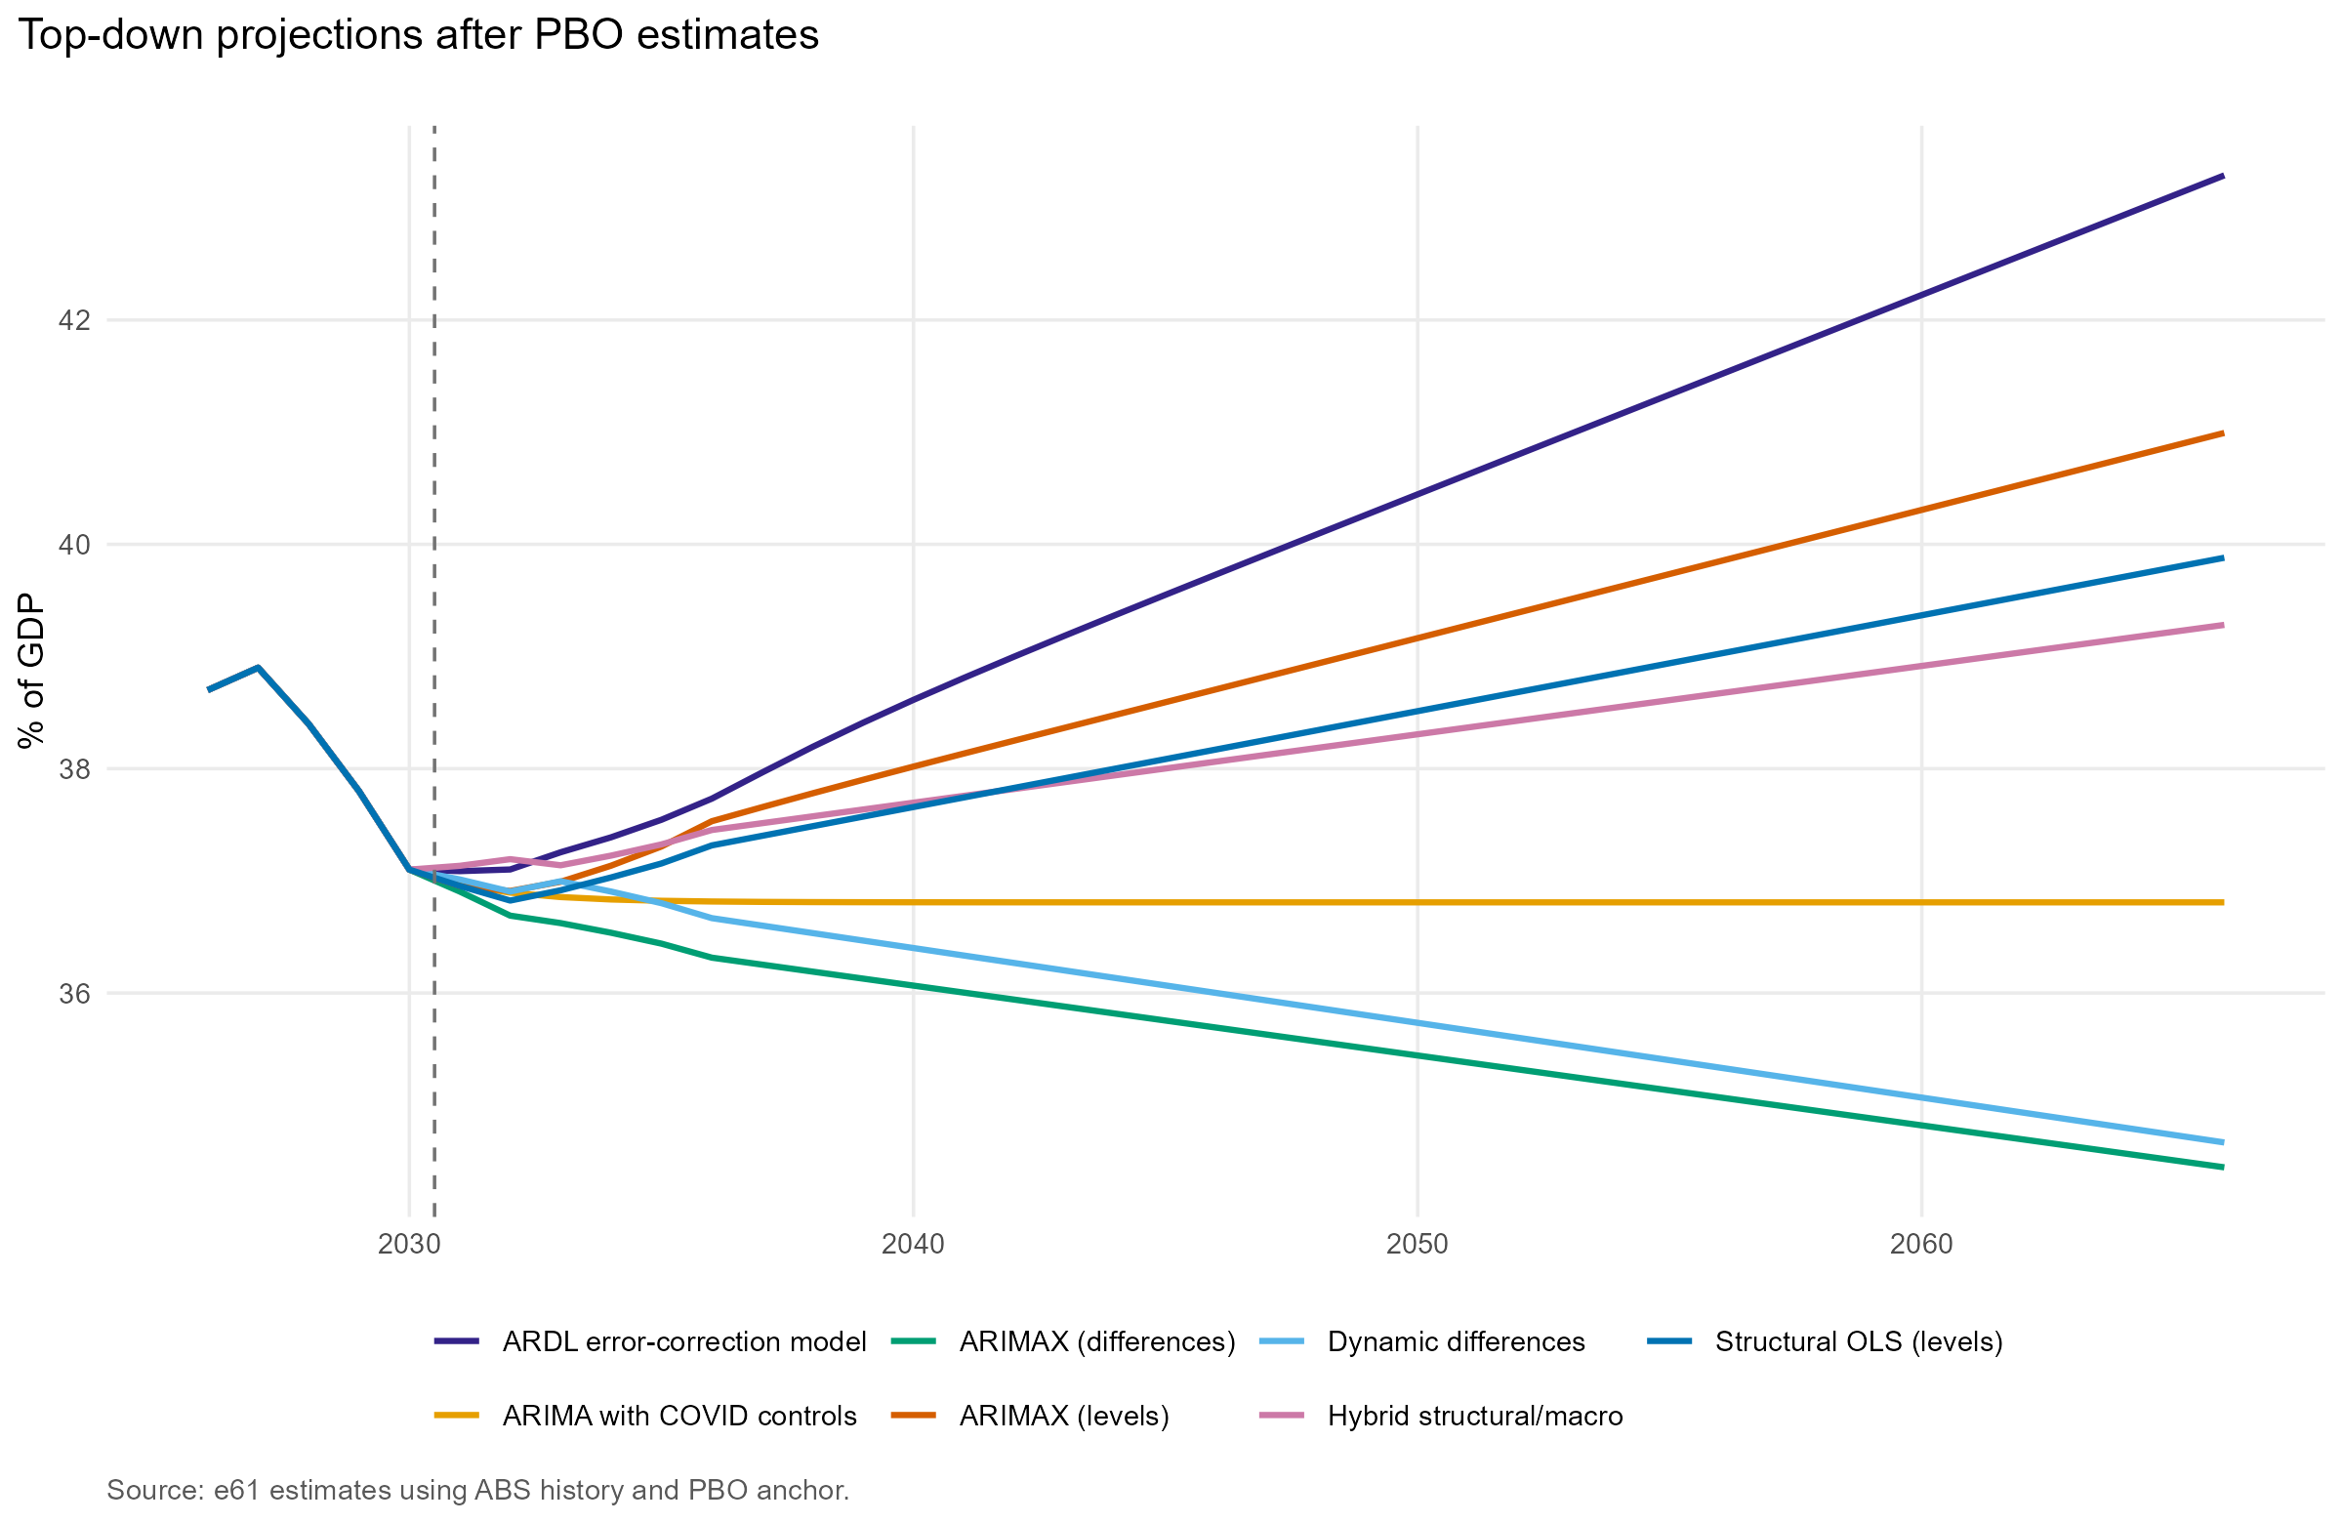
Figure 7. Official forecast followed by each top-down model's projected change.
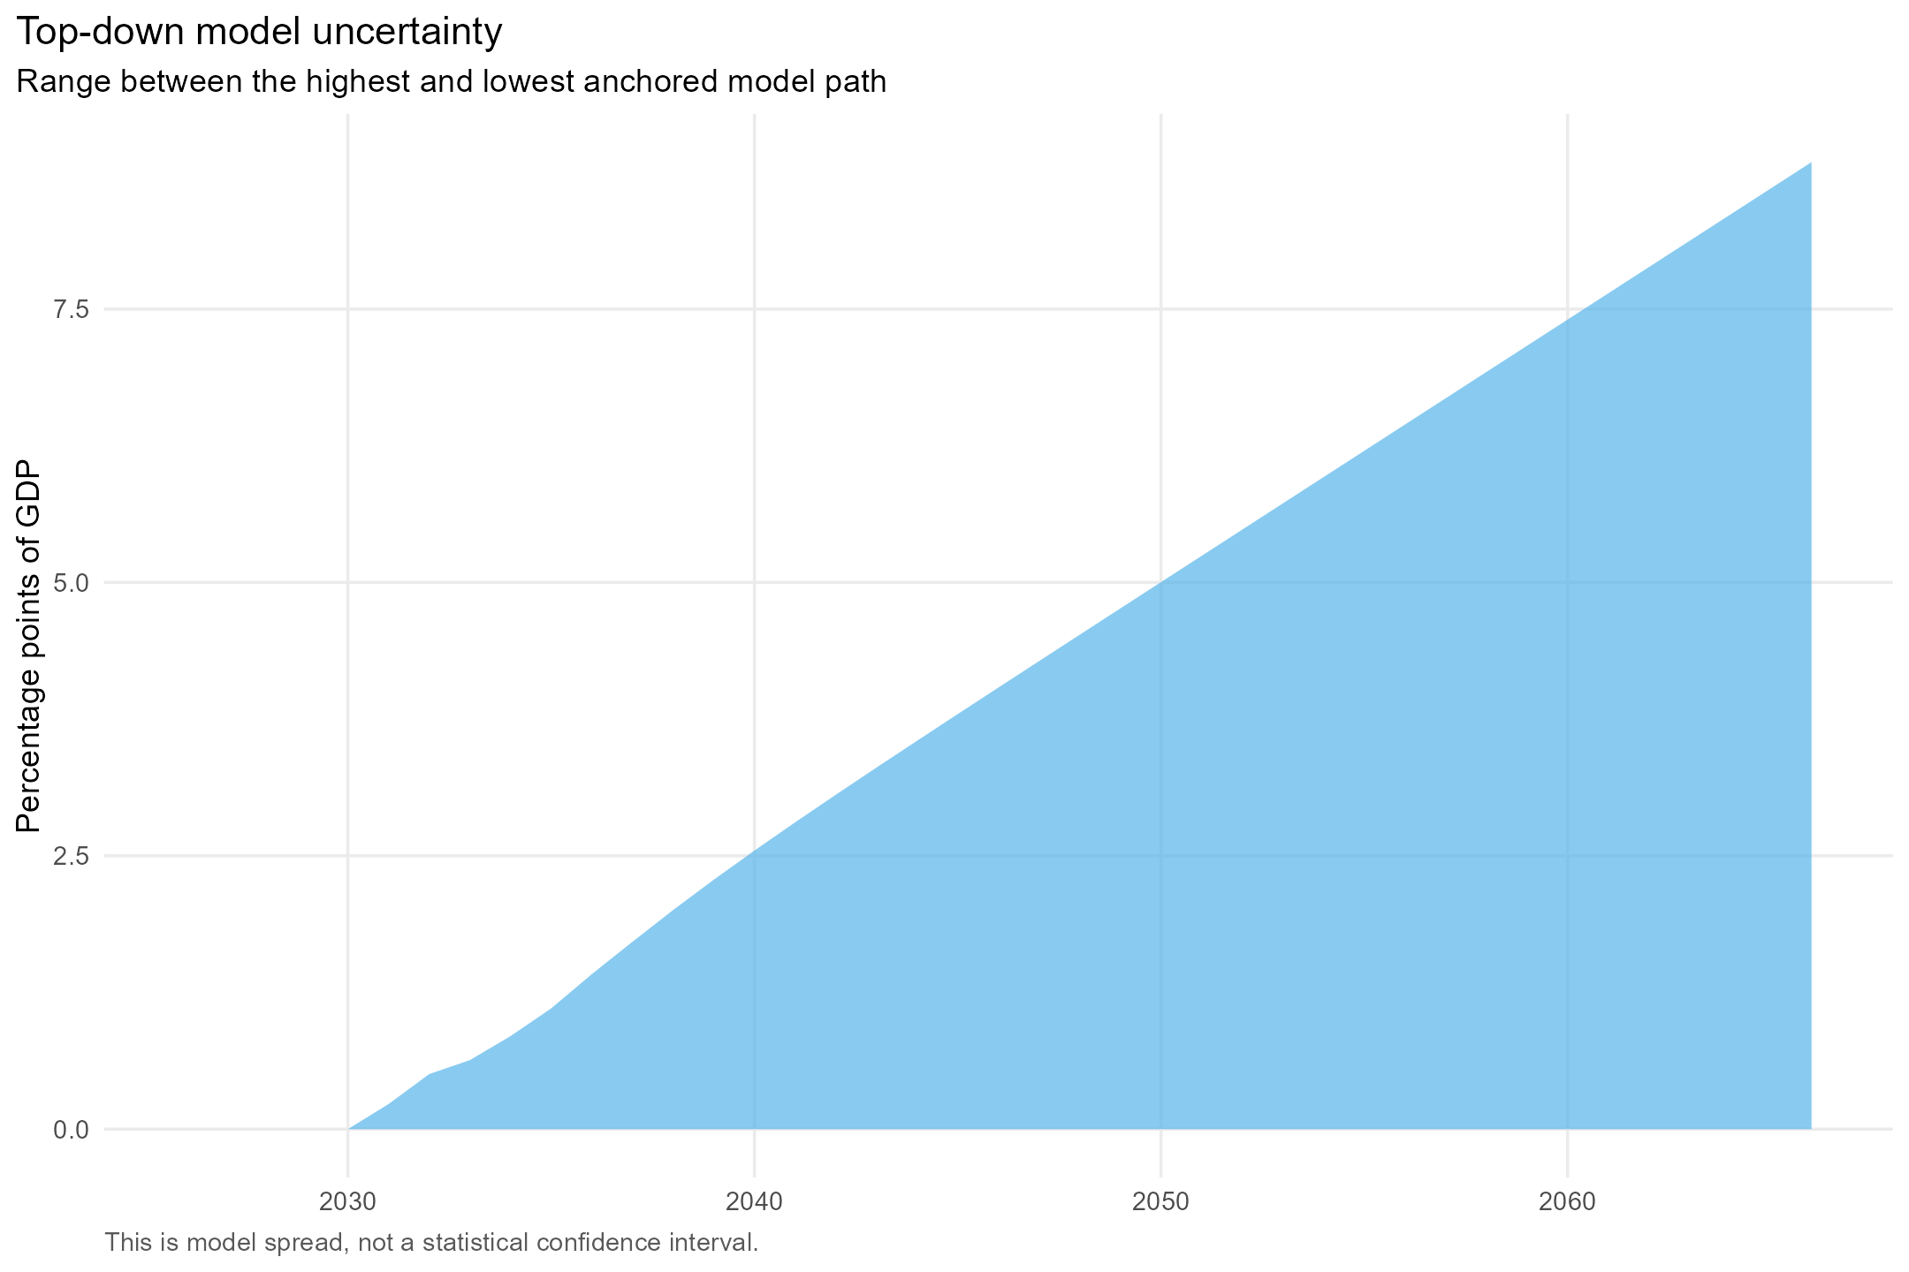
Figure 8. Dispersion across the anchored top-down paths.

Shapley attribution diagnostic
The structural factors are also used to decompose the observed change from 2000 to 2025. For each coalition of factor groups, the regression is re-estimated and its fitted change is calculated. A factor's contribution is its average incremental fitted effect across all 120 possible orderings. The residual is reported separately so the components reconcile to the observed change. This preserves the earlier Shapley approach as an attribution exercise; it is not treated as a forecasting model or a causal decomposition.
Component | Contribution (percentage points of GDP)
Demography | 1.67
Terms of trade | 0.36
Relative government prices | 0.11
Unemployment | 0.01
COVID period | -0.76
Residual / unexplained change | 2.48
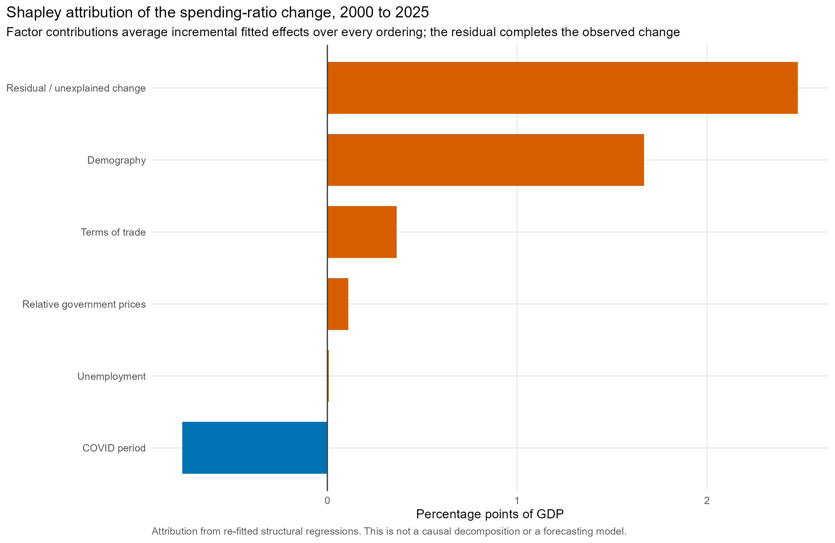
Figure 9. Shapley attribution of the historical change in the broad spending ratio.

7. Forecast-period checks
Two checks are reported. First, rolling origins from 2009-10 to 2019-20 estimate each top-down model using only data then available and project one to five years ahead. Future explanatory variables are set to their realised values, so this is a conditional model check rather than a real-time forecast exercise. Second, all models are estimated on the full historical sample and run without the PBO anchor over 2025-26 to 2029-30; their paths are compared with the current official forecast.
Model | Horizon | MAE (percentage points) | RMSE (percentage points)
Structural OLS (levels) | 1 year | 2.32 | 3.27
ARIMAX (levels) | 1 year | 1.82 | 2.91
ARIMAX (differences) | 1 year | 1.05 | 1.71
Dynamic differences | 1 year | 1.07 | 1.71
Hybrid structural/macro | 1 year | 1.65 | 3.08
ARDL error-correction model | 1 year | 1.37 | 2.16
ARIMA with COVID controls | 1 year | 1.39 | 2.63
Structural OLS (levels) | 5 years | 6.15 | 6.68
ARIMAX (levels) | 5 years | 5.95 | 6.45
ARIMAX (differences) | 5 years | 3.90 | 4.97
Dynamic differences | 5 years | 3.97 | 5.00
Hybrid structural/macro | 5 years | 5.59 | 6.13
ARDL error-correction model | 5 years | 6.42 | 7.36
ARIMA with COVID controls | 5 years | 2.12 | 2.94
Model | Approach | Mean difference (pp) | MAE versus official (pp) | Maximum absolute difference (pp)
Structural OLS (levels) | Top-down model-only | -1.97 | 1.97 | 2.61
ARIMAX (levels) | Top-down model-only | -0.26 | 0.37 | 0.65
ARIMAX (differences) | Top-down model-only | -0.03 | 0.39 | 0.70
Dynamic differences | Top-down model-only | 0.22 | 0.49 | 1.15
Hybrid structural/macro | Top-down model-only | 0.65 | 0.75 | 1.88
ARDL error-correction model | Top-down model-only | 0.05 | 0.45 | 0.95
ARIMA with COVID controls | Top-down model-only | -1.48 | 1.48 | 1.97
Bottom-up model-only | Bottom-up model-only | 1.65 | 1.76 | 3.52
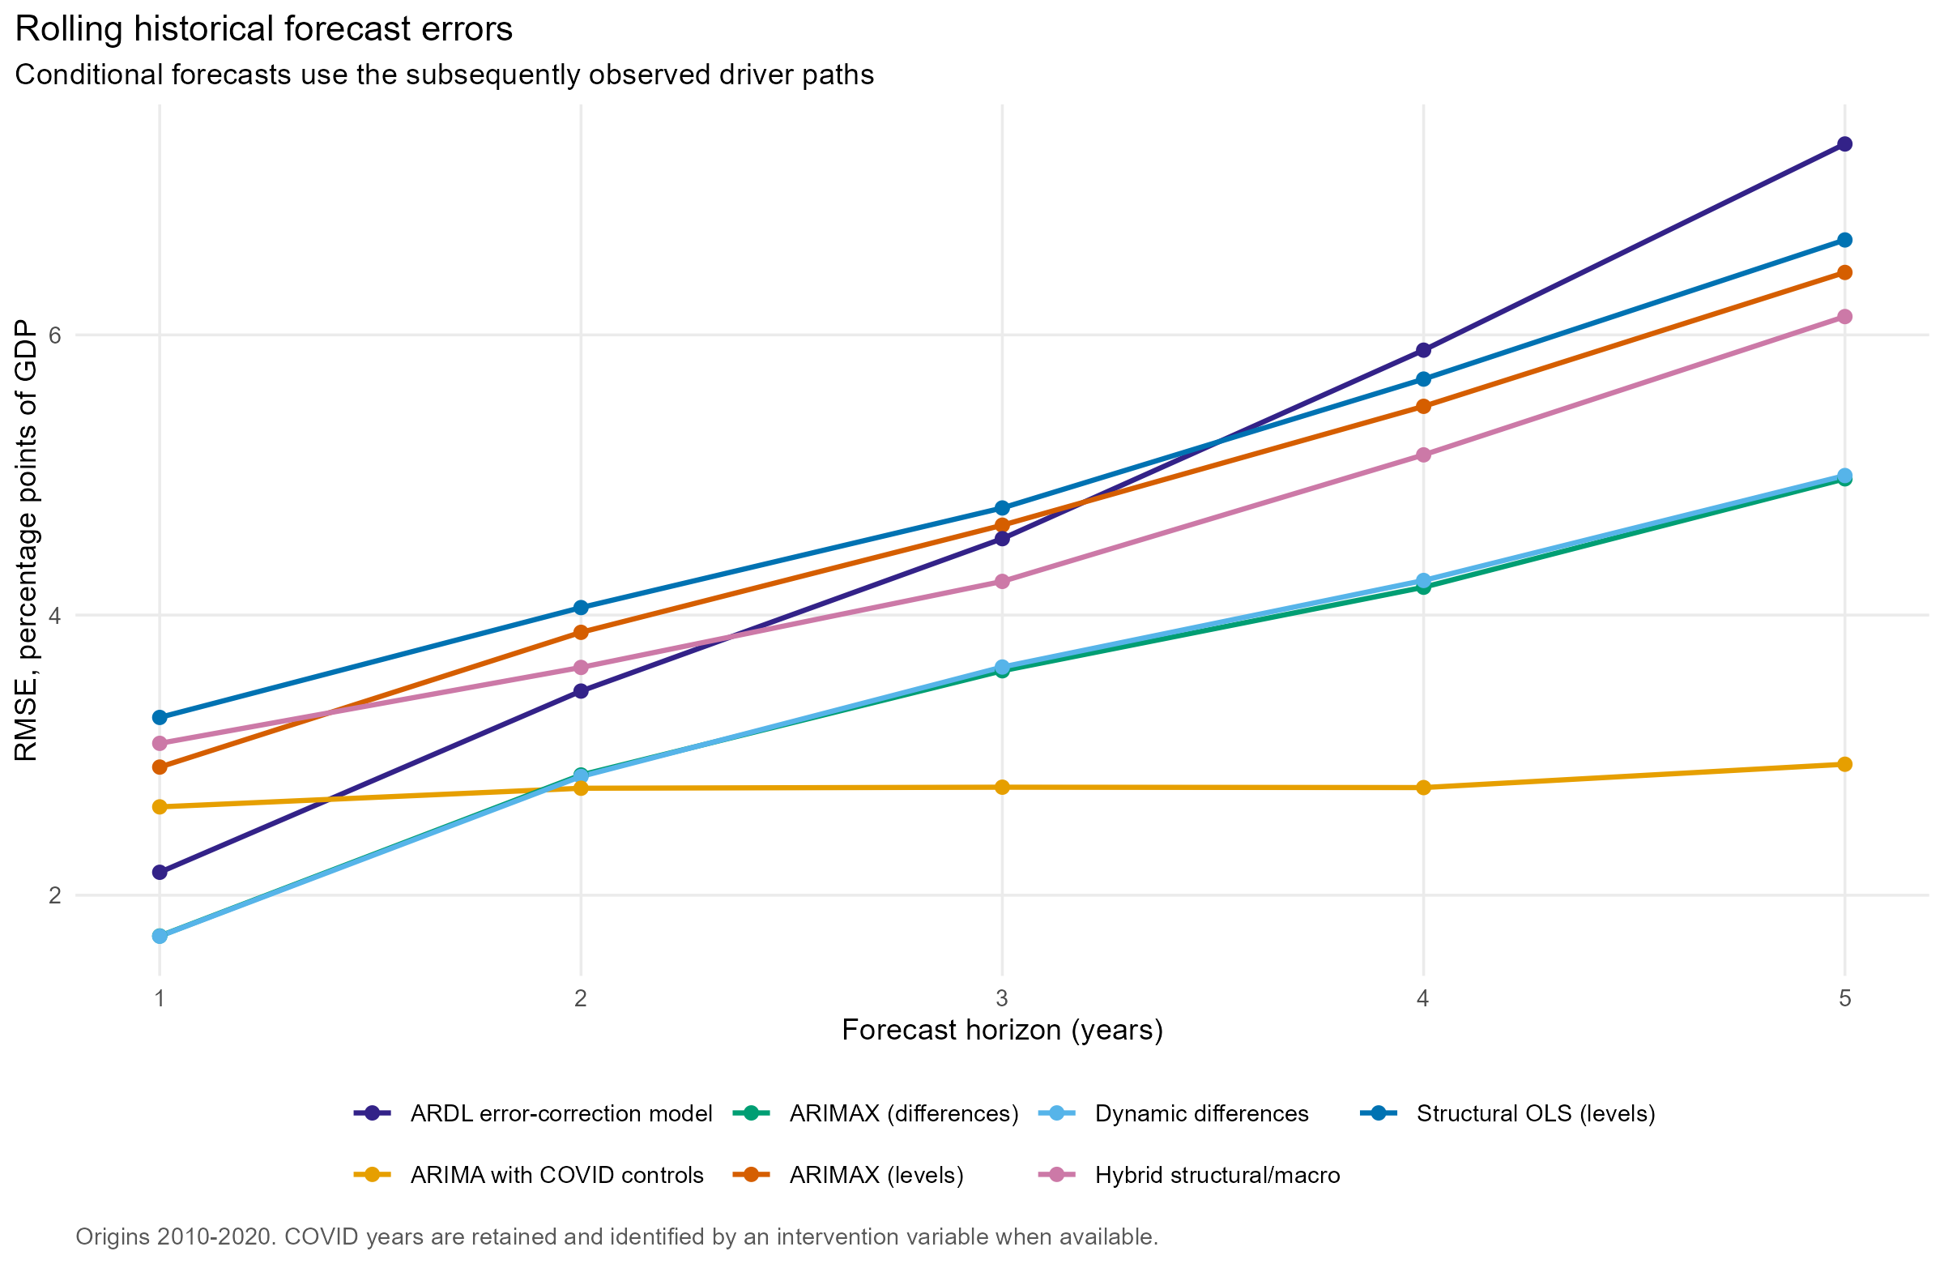
Figure 10. Rolling historical RMSE by forecast horizon.
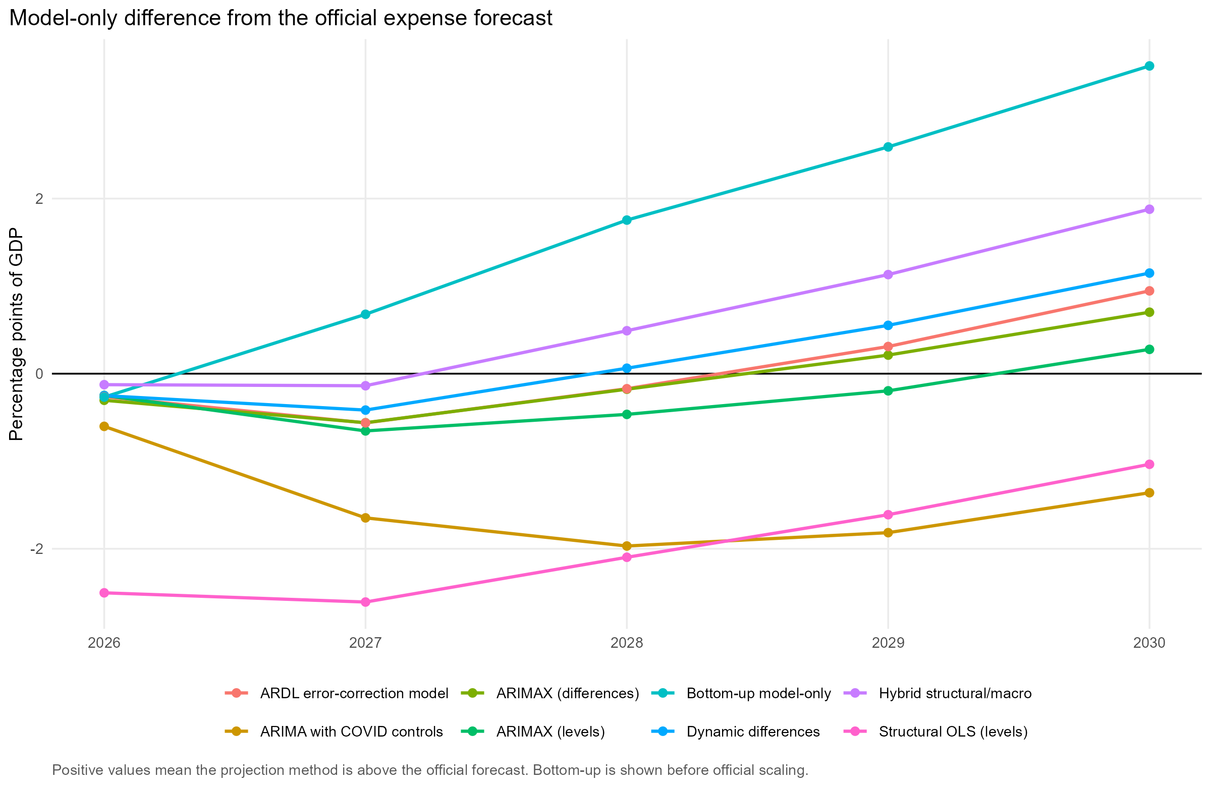
Figure 11. Unanchored model paths minus the official expense forecast.
Interpretation: a model may be useful as a long-run scenario even if it misses the official near-term path, because the latter includes policy decisions, budget measures and forecast judgement absent from parsimonious historical equations. Conversely, short-horizon fit does not validate a model's long-run causal interpretation. The top-down equations are predictive associations, not causal estimates.

8. Revenue and taxes
Revenue is external to the spending models. PBO consolidated revenue is used through 2029-30. The central and restraint paths then raise revenue by 1.2 percentage points of GDP by 2036-37, while the pressure path raises it by 0.6 percentage points. These are transparent policy/elasticity assumptions, not tax microsimulation results.
An indexed-threshold sensitivity holds revenue/GDP at its final official-forecast value. This is a simple proxy for removing fiscal drag from personal income-tax thresholds; it is not an estimate of the full tax system under indexation. A fuller tax module should separately project personal income tax, company tax, GST/excises and non-tax revenue using tax bases, elasticities, policy measures and threshold schedules.
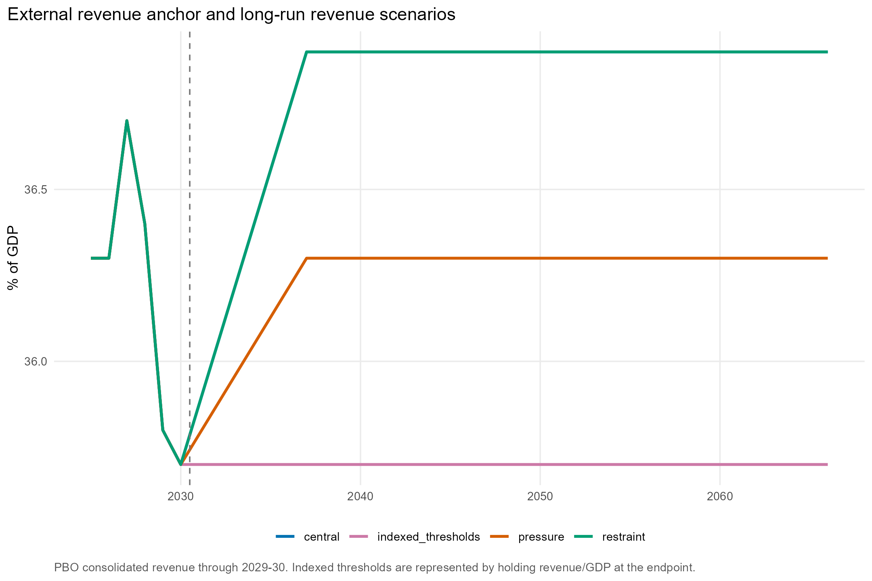
Figure 12. Consolidated revenue scenarios.

9. Debt accumulation
The bottom-up debt model separates primary spending and interest. Let d be net debt/GDP, g nominal GDP growth, i the effective interest rate, p primary expenses/GDP, k net capital investment/GDP, r revenue/GDP and s a stock-flow adjustment. The recursion is: opening debt on current-year GDP = d[t-1] / (1 + g[t]); interest/GDP = i[t] * opening debt; d[t] = opening debt + p[t] + interest[t] + k[t] - r[t] + s[t].
The top-down model projects total expenses, so interest is already embedded in the aggregate series. Its debt path therefore omits a separate debt-interest feedback and should be read as a diagnostic comparison, not as the preferred debt result. Effective interest rates transition from the official implied rate to the scenario long-run rate.
Scenario | Defence target / GDP | Target year | Long-run effective interest rate | Net capital investment / GDP | Revenue increase after forecast | Annual stock-flow adjustment
Central | 2.5% | 2034-35 | 4.4% | 1.5% | 1.2 pp | 0.00 pp
Pressure | 3.0% | 2034-35 | 5.2% | 1.8% | 0.6 pp | 0.25 pp
Restraint | 2.2% | 2034-35 | 3.8% | 1.2% | 1.2 pp | -0.10 pp
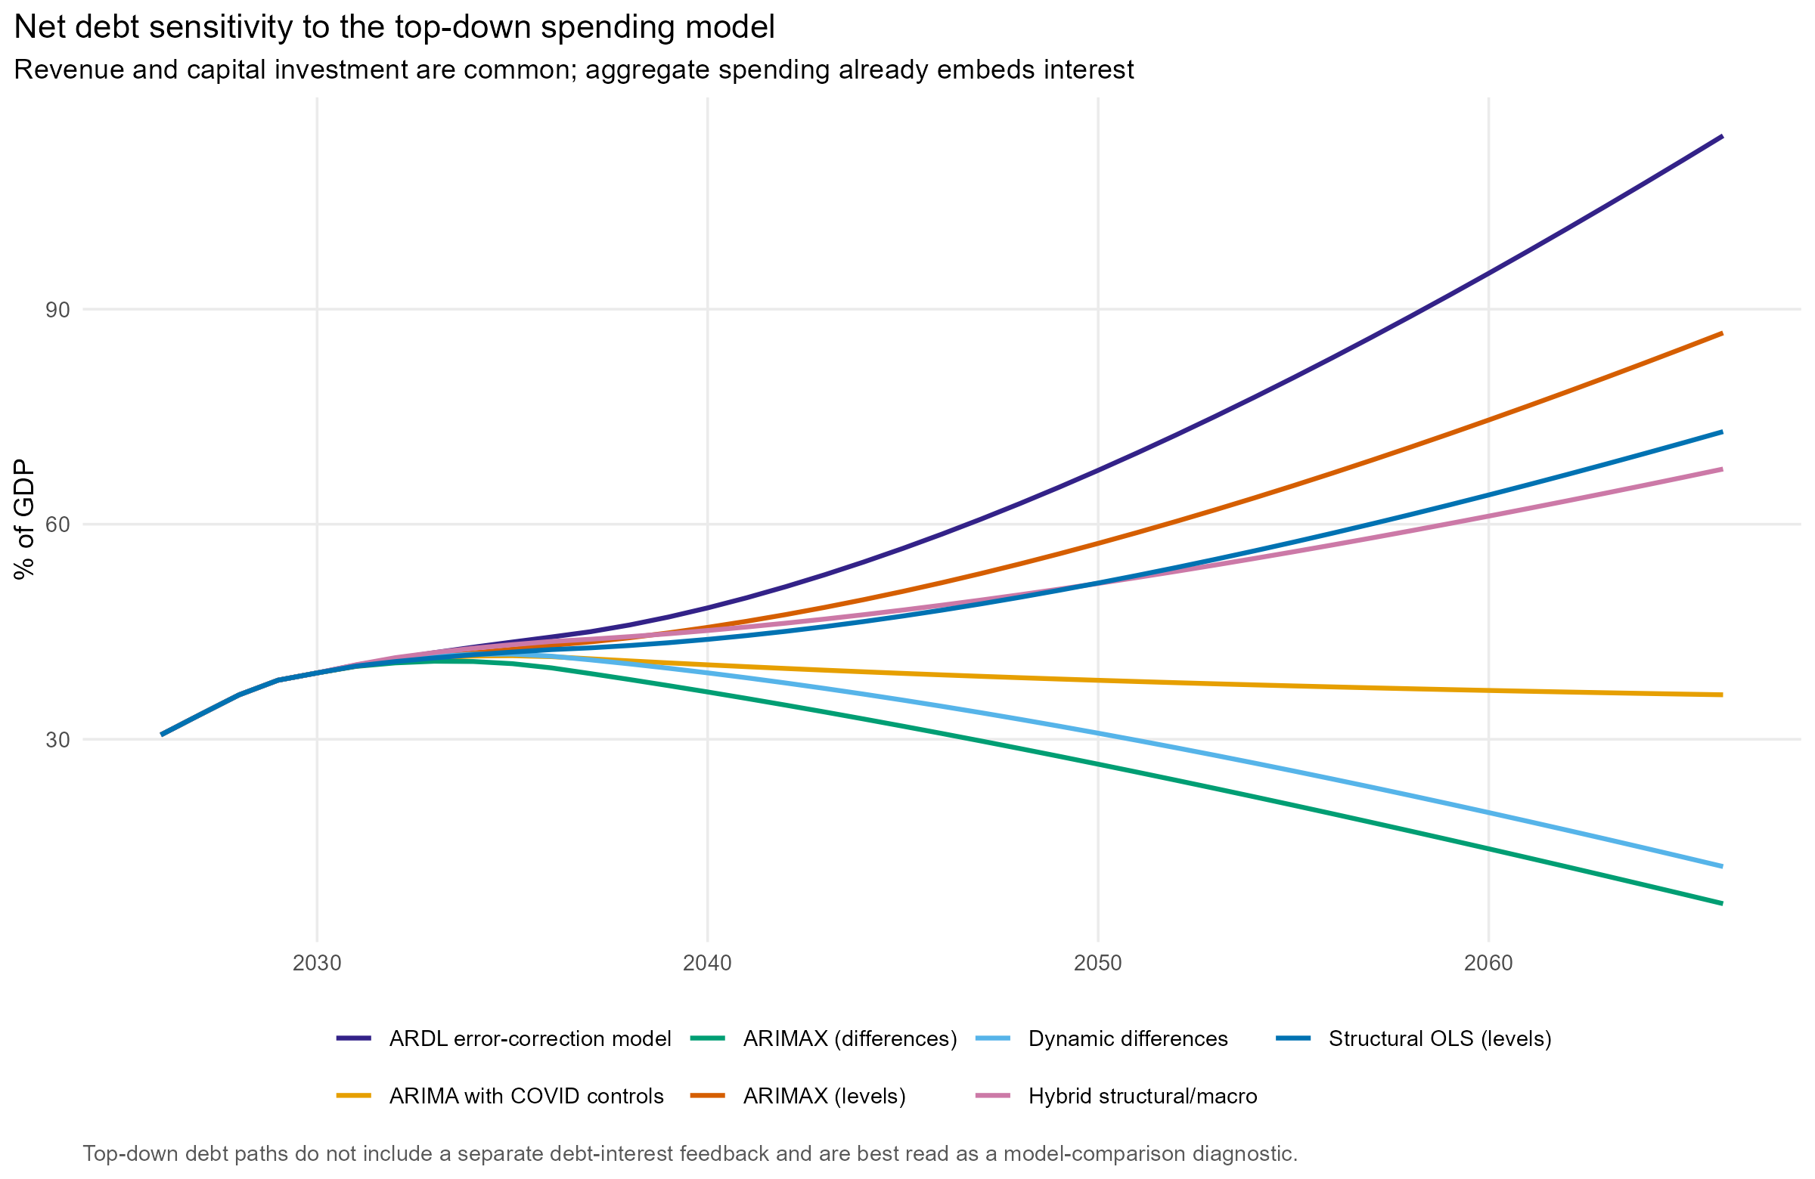
Figure 13. Diagnostic debt paths implied by the top-down total-expense models.

10. Selected scenario results
The following values are mechanical outputs of the stated assumptions. They are not point forecasts and should be read with the scenario definitions and limitations.
Financial year | Scenario | Primary expenses / GDP | Net debt / GDP
2028-29 | Central | 34.1% | 30.9%
2028-29 | Pressure | 34.1% | 32.1%
2028-29 | Restraint | 34.1% | 30.4%
2034-35 | Central | 34.4% | 27.2%
2034-35 | Pressure | 35.6% | 38.4%
2034-35 | Restraint | 33.8% | 21.5%
2049-50 | Central | 36.7% | 31.1%
2049-50 | Pressure | 40.2% | 110.5%
2049-50 | Restraint | 34.6% | -3.3%
2065-66 | Central | 39.4% | 75.2%
2065-66 | Pressure | 45.9% | 298.4%
2065-66 | Restraint | 35.4% | -13.9%
Model | Total expenses / GDP in 2065-66 | Net debt / GDP in 2065-66
ARDL error-correction model | 43.3% | 114.2%
ARIMA with COVID controls | 36.8% | 36.2%
ARIMAX (differences) | 34.4% | 7.1%
ARIMAX (levels) | 41.0% | 86.7%
Dynamic differences | 34.7% | 12.2%
Hybrid structural/macro | 39.3% | 67.7%
Structural OLS (levels) | 39.9% | 72.9%

11. Bottom-up/top-down comparison and statistical diagnostics
The comparison places the central bottom-up total-expense path and all seven top-down total-expense paths on one chart. The bottom-up line adds endogenous debt interest to projected primary categories. The top-down equations project total expenses directly, so they do not have a separate interest feedback. The comparison is therefore economically informative, but the two approaches remain structurally different.
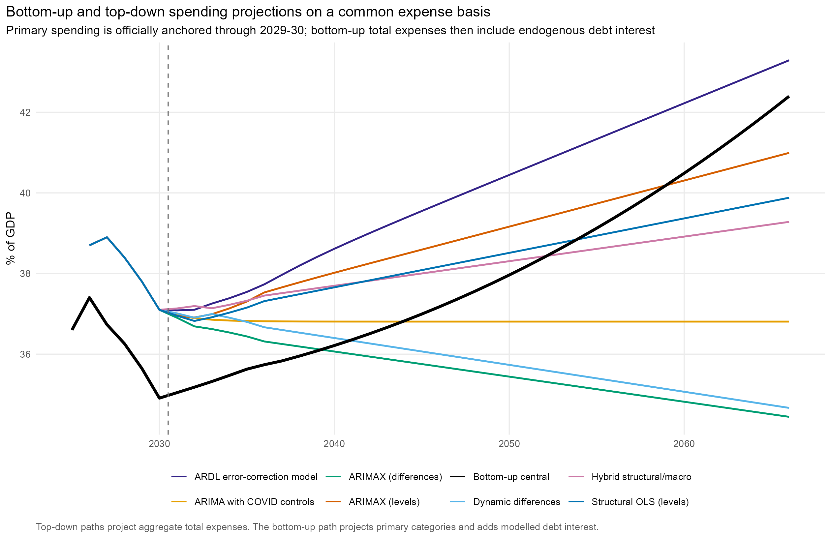
Figure 14. Central bottom-up total expenses compared with all anchored top-down estimates.
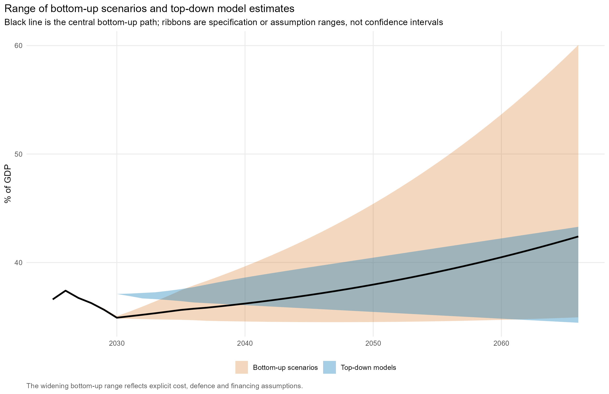
Figure 15. Bottom-up scenario range compared with top-down model spread.

Recommended approach
Horizon or use | Recommended approach | Reason
Official forecast period | Published PBO consolidated forecast | Contains current policy, budget measures, near-term macro judgement and consolidated fiscal information absent from parsimonious equations.
Central long-run fiscal projection | Bottom-up purpose model with endogenous interest and explicit revenue scenarios | Maps ageing, service demand, excess costs, defence, revenue and interest feedback into auditable category paths; its assumptions can be replaced directly as policy information improves.
Primary top-down long-run cross-check | Dynamic-difference model, reviewed against the full structural-model ensemble | The dynamic-difference model has the strongest five-year rolling result among the driver-based models and the lowest tested endpoint-window sensitivity. The ECM remains an experimental sensitivity because a valid long-run level relationship must be established separately.
Near-term statistical benchmark | ARIMA with COVID controls | Provides the strongest short-horizon statistical benchmark, but no structural response to demographic, economic or policy changes.
Uncertainty and stress testing | Bottom-up scenarios plus the spread and sensitivities across all top-down specifications | No single model captures parameter, specification, policy and macro uncertainty; scenario and model spread are complementary diagnostics rather than probability intervals.
The central recommendation is therefore a layered framework, not a mechanical choice of the equation with the highest in-sample R-squared. Official forecasts contain policy and budget information. Beyond that horizon, the bottom-up model is best suited to the fiscal-sustainability question because it identifies which services, demographic exposures, cost assumptions, revenue choices and interest feedbacks drive the debt path. Its weakness is that calibrated assumptions do not generate statistical standard errors, so those assumptions must be stress-tested and documented.
Among the driver-based top-down equations, the dynamic-difference specification has the lowest five-year rolling RMSE and the smallest maximum endpoint shift across the tested estimation windows in this vintage. Its long-run innovation interval is wide because annual errors accumulate, so it remains a cross-check rather than a stand-alone central forecast. The ARDL bounds tests do not support the fitted long-run relationship despite acceptable residual and functional-form checks. The ECM should therefore remain an experimental sensitivity rather than the preferred projection equation.
The ARIMA with COVID controls is the best near-term statistical benchmark in this vintage. Its comparatively flat path cannot respond to ageing, relative prices, unemployment, policy or service-specific pressures, so it should not be selected as the long-run fiscal model merely because its short-horizon errors are smaller.
Model | In-sample R2 | In-sample RMSE (pp) | Rolling RMSE: 1 year (pp) | Rolling RMSE: 5 years (pp) | Official-period MAE (pp) | Maximum sample-window shift (pp) | Conditional 95% width in 2065-66 (pp)
ARDL error-correction model | 0.896 | 0.62 | 2.16 | 7.36 | 0.45 | 11.65 | 4.90
ARIMAX (differences) | 0.878 | 0.67 | 1.71 | 4.97 | 0.39 | 2.29 | 18.16
ARIMAX (levels) | 0.892 | 0.63 | 2.91 | 6.45 | 0.37 | 7.72 | 6.09
Dynamic differences | 0.881 | 0.66 | 1.71 | 5.00 | 0.49 | 2.50 | 19.38
Hybrid structural/macro | 0.837 | 0.77 | 3.08 | 6.13 | 0.75 | 6.31 | 20.05
Structural OLS (levels) | 0.709 | 1.03 | 3.27 | 6.68 | 1.97 | 6.60 | 10.53
ARIMA with COVID controls | 0.835 | 0.78 | 2.63 | 2.94 | 1.48 | 0.40 | 6.60
No single column determines the recommendation. In-sample fit rewards close historical tracking; rolling RMSE tests pseudo-out-of-sample stability; official-period MAE tests consistency with current forecast judgement; estimation-window shifts reveal specification instability; and conditional interval width shows how innovations accumulate within the model. These criteria answer different questions and should be read together.

Diagnostic coverage
Approach | Model fit | Sensitivity | Standard errors
Top-down estimated models | In-sample level fit, residual autocorrelation and normality diagnostics; supplemented by rolling forecast errors | Alternative estimation windows and four controlled driver shocks | Coefficient standard errors and conditional model-only forecast intervals
Bottom-up calibrated projection | No conventional in-sample statistical fit: categories are calibrated to GFS and scaled to the official forecast; raw forecast-period differences are reported | Central, pressure and restraint assumption scenarios plus revenue sensitivities | Not applicable without estimated category equations; scenario spread is not a confidence interval
Conventional regression standard errors are not reported for the bottom-up categories because their excess-cost and exposure parameters are calibrated assumptions, not estimated coefficients. Bottom-up uncertainty is represented by transparent scenario sensitivity. Treating that scenario spread as a statistical confidence interval would be misleading.

In-sample fit and residual tests
Model | R-squared | MAE (pp) | RMSE (pp) | Ljung-Box p-value | Shapiro-Wilk p-value
Structural OLS (levels) | 0.709 | 0.71 | 1.03 | 0.001 | 0.000
ARIMAX (levels) | 0.892 | 0.49 | 0.63 | 0.349 | 0.392
ARIMAX (differences) | 0.878 | 0.51 | 0.67 | 0.102 | 0.821
Dynamic differences | 0.881 | 0.50 | 0.66 | 0.125 | 0.884
Hybrid structural/macro | 0.837 | 0.56 | 0.77 | 0.440 | 0.281
ARDL error-correction model | 0.896 | 0.43 | 0.62 | 0.562 | 0.119
ARIMA with COVID controls | 0.835 | 0.63 | 0.78 | 0.680 | 0.755
The ARDL error-correction equation has the lowest in-sample RMSE and highest in-sample R-squared in this vintage, followed by the dynamic-difference and levels-ARIMAX specifications. The structural OLS Ljung-Box result indicates residual serial correlation, supporting models with explicit dynamics. Low Shapiro-Wilk p-values for some specifications warn against interpreting normal-theory intervals too literally. In-sample fit is not a model-selection rule: rolling forecast performance remains the more relevant short-horizon check.
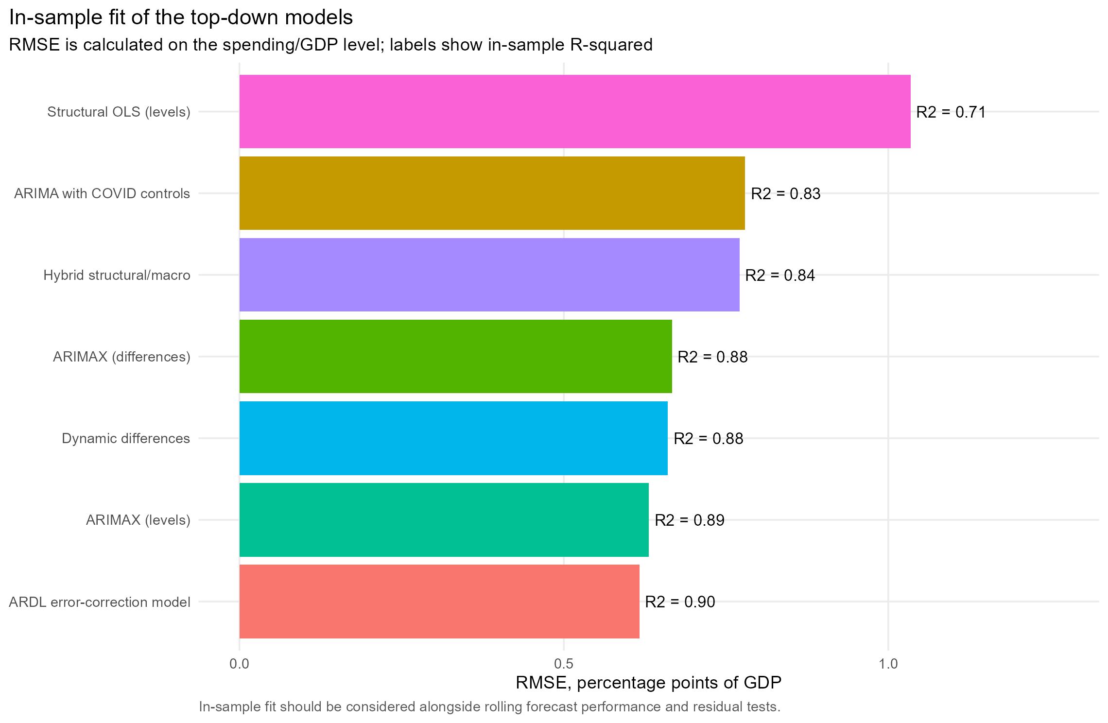
Figure 16. In-sample fit on the broad spending/GDP level.

Coefficient standard errors and forecast intervals
The output table model_coefficient_standard_errors.csv reports conventional standard errors for every estimated coefficient, HC1 heteroskedasticity-robust standard errors for the OLS equations, and maximum-likelihood covariance-matrix standard errors for ARIMA coefficients. These quantify sampling uncertainty conditional on each chosen equation; they do not cover model selection, data revisions or the assumed driver paths.
Term | Estimate | Conventional SE | Robust HC1 SE | Robust p-value
age_0_14 | 0.6428 | 0.2472 | 0.2579 | 0.013
age_65p | 0.8259 | 0.2871 | 0.3173 | 0.009
tot_z | 0.0045 | 0.0034 | 0.0021 | 0.032
rp_z | -0.0020 | 0.0021 | 0.0020 | 0.301
unemployment | 0.0079 | 0.0015 | 0.0010 | 0.000
covid_fy2020 | 0.0332 | 0.0124 | 0.0049 | 0.000
covid_fy2021 | 0.0435 | 0.0129 | 0.0066 | 0.000
covid_fy2022 | 0.0107 | 0.0133 | 0.0087 | 0.218
Model | Model-only mean | Forecast standard error | Lower 95% | Upper 95%
Structural OLS (levels) | 38.8% | 2.69 pp | 33.6% | 44.1%
ARIMAX (levels) | 41.3% | 1.54 pp | 38.2% | 44.3%
ARIMAX (differences) | 35.1% | 4.71 pp | 26.2% | 44.3%
Dynamic differences | 35.9% | 4.94 pp | 26.2% | 45.5%
Hybrid structural/macro | 41.3% | 5.22 pp | 31.0% | 51.1%
ARDL error-correction model | 44.2% | 1.24 pp | 41.9% | 46.8%
ARIMA with COVID controls | 35.5% | 1.69 pp | 32.1% | 38.7%
The forecast intervals are conditional model-only intervals. The economic and demographic paths are fixed. ARIMA intervals include simulated future innovations, the ECM recursively propagates simulated equation innovations, and all estimated coefficients are held fixed; structural OLS uses a conventional prediction interval. These ranges should not be combined mechanically with bottom-up scenario ranges.
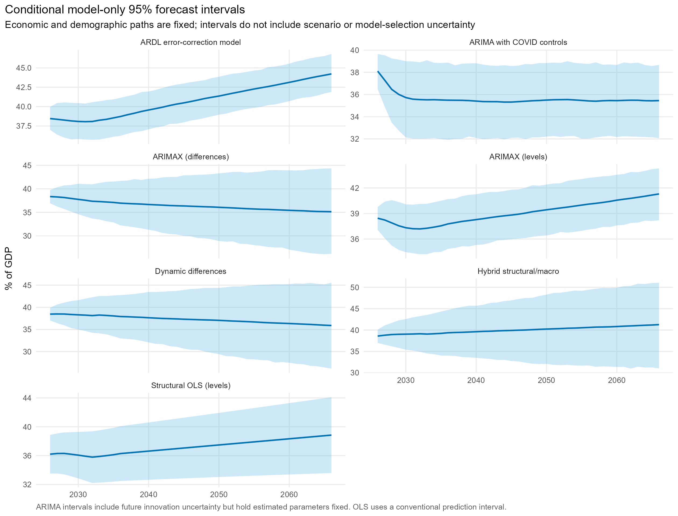
Figure 17. Conditional model-only 95% intervals for each top-down model.

Sensitivity tests
Model | Estimation window | 2065-66 change from full sample (pp)
ARDL error-correction model | Starts 1990 | -1.45
ARDL error-correction model | Estimated through 2019 | -11.65
ARIMAX (differences) | Starts 1990 | 2.29
ARIMAX (differences) | Estimated through 2019 | -1.02
ARIMAX (levels) | Starts 1990 | 0.45
ARIMAX (levels) | Estimated through 2019 | -7.72
Dynamic differences | Starts 1990 | 2.50
Dynamic differences | Estimated through 2019 | -0.85
Hybrid structural/macro | Starts 1990 | 2.33
Hybrid structural/macro | Estimated through 2019 | -6.31
Structural OLS (levels) | Starts 1990 | 0.77
Structural OLS (levels) | Estimated through 2019 | -6.60
ARIMA with COVID controls | Starts 1990 | 0.40
ARIMA with COVID controls | Estimated through 2019 | 0.29
Estimation-window sensitivity is material: several structural endpoints move by multiple percentage points when estimation begins in 1990 or ends before COVID. Driver sensitivities phase in one controlled change at a time: one percentage point more population aged 65 and over, one percentage point higher unemployment, or a one-standard-deviation change in the terms of trade or relative government prices. The univariate benchmark is unaffected by construction because it has no external drivers.
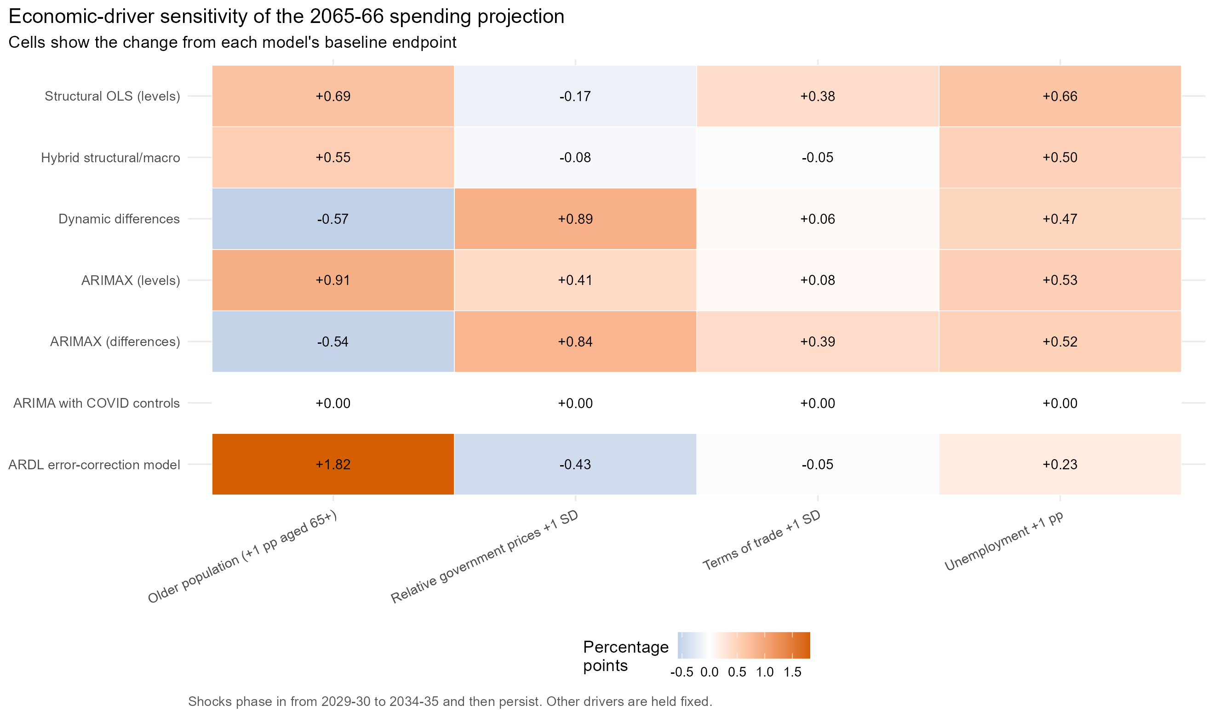
Figure 18. Effect of controlled driver changes on each model's 2065-66 endpoint.
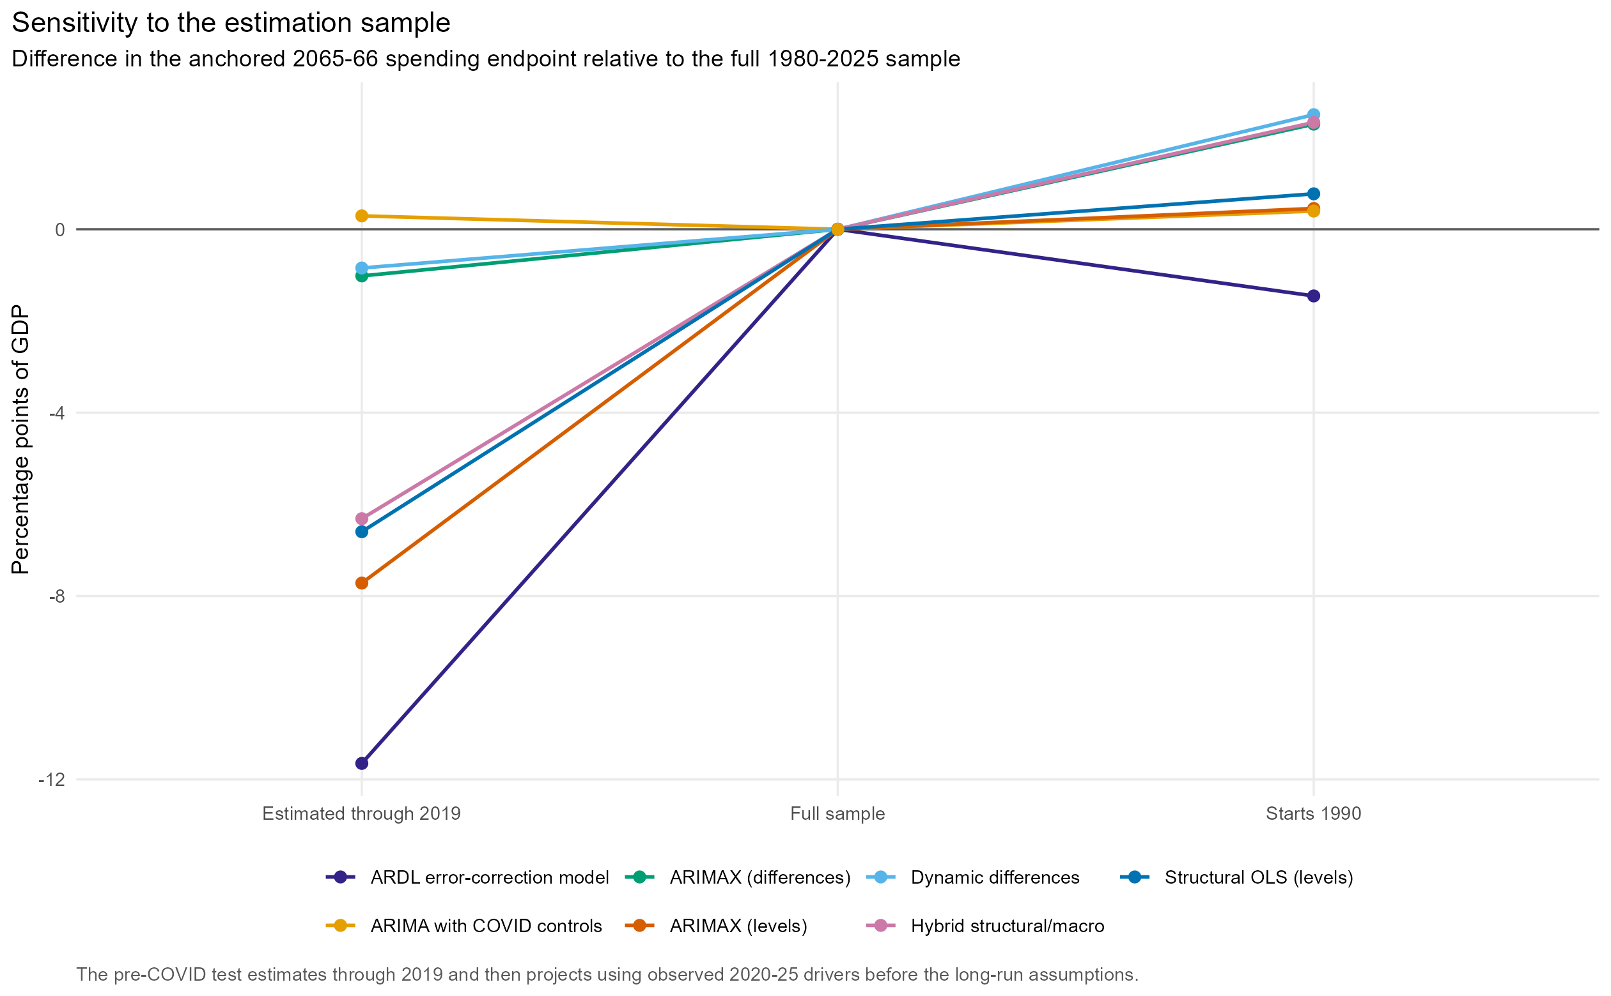
Figure 19. Sensitivity of the 2065-66 endpoint to the estimation sample.

12. Limitations and next development priorities
- Only ten annual observations are available in the current GFS purpose table. The bottom-up category model is consequently calibrated, not econometrically estimated by category.
- The Centre for Population workbook publishes selected long-run years; intermediate annual age structures are interpolated. This is appropriate for smooth exposure paths but does not reproduce a full cohort-component model.
- The official anchor is the PBO 2026-27 consolidated outlook. Individual Commonwealth or state budget numbers do not by themselves replace this consolidated national forecast.
- The national-accounts and GFS/PBO spending concepts differ. Anchoring changes at the join is transparent but does not create a detailed accounting bridge.
- Excess-cost, defence, revenue, investment, interest and stock-flow assumptions are illustrative. Policy-costed scenarios should replace them where available.
- Conditional model-only forecast intervals hold coefficients and driver paths fixed. Model spread is specification uncertainty, while pressure/restraint paths are assumption sensitivities; neither is a statistical probability interval.
- The next valuable extension is a modular revenue block with tax-specific bases and elasticities, followed by stochastic macro shocks and parameter uncertainty.

13. Reproduction and audit trail
The complete run writes CSV tables, fitted-model RDS files, a source manifest, validation checks, figures and this report. Review data_validation.csv first, then the unanchored forecast comparison, before interpreting long-run debt endpoints. All important scenario levers are in scripts/03_assumptions.R.

